Test #3

CSCI-3400 - Fall-2022

+++++++++++++++++++++++++++++++++++++++++++++++++++++++++++++++++++++

**Instruction: Write clearly and give full justification to each question. Show all your MATHEMAICAL working.**

+++++++++++++++++++++++++++++++++++++++++++++++++++++++++++++++

**Name: __________________________________**

**E#:_____________________________________**

|  |  |  |
| --- | --- | --- |
| Questions | Max Points | Earned Points |
| 1 | 10 |  |
| 2 | 10 |  |
| 3 | 10 |  |
| 4 | 10 |  |
| 5 | 10 |  |
| 6 | 10 |  |
| 7 | 10 |  |
| 8 | 10 |  |
| 9 | 10 |  |
| 10 | 10 |  |
| Total | **100** |  |

**IMPORTANT**

* You can use online references, but **write answers in your own words**!  **Cite any references used**. Answer the question in your own words, no credit will be given for answers copied from any source*.*
* No collaborating with other people; a **0** will be given if any collaboration evidence is found.  Ask me for a hint if you are stuck on any particular problem.
* I am looking for very specific, detailed, correct, and complete answers.
* Most answers found on the Internet (especially Wikipedia) are generic answers for people without any network background and are not any of the above! Research each problem completely.
* Turn in a Word document or pdf into the Dropbox.

1. Explain in detail, the concept of channel partitioning using MAC protocols. You can use either TDMA or FDMA?
2. Consider the following graph G = (N, E).

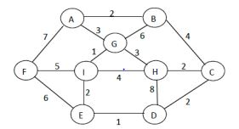

1. List the set of routers:
2. List the set of links:
3. Consider the following graph. Find the shortest distance starting from ***A t***o ***F*** nodes using Dijkstra’s Algorithm. Make sure you show how you traverse the graph by highlighting each link for each iteration. Add extra sheet in needed.

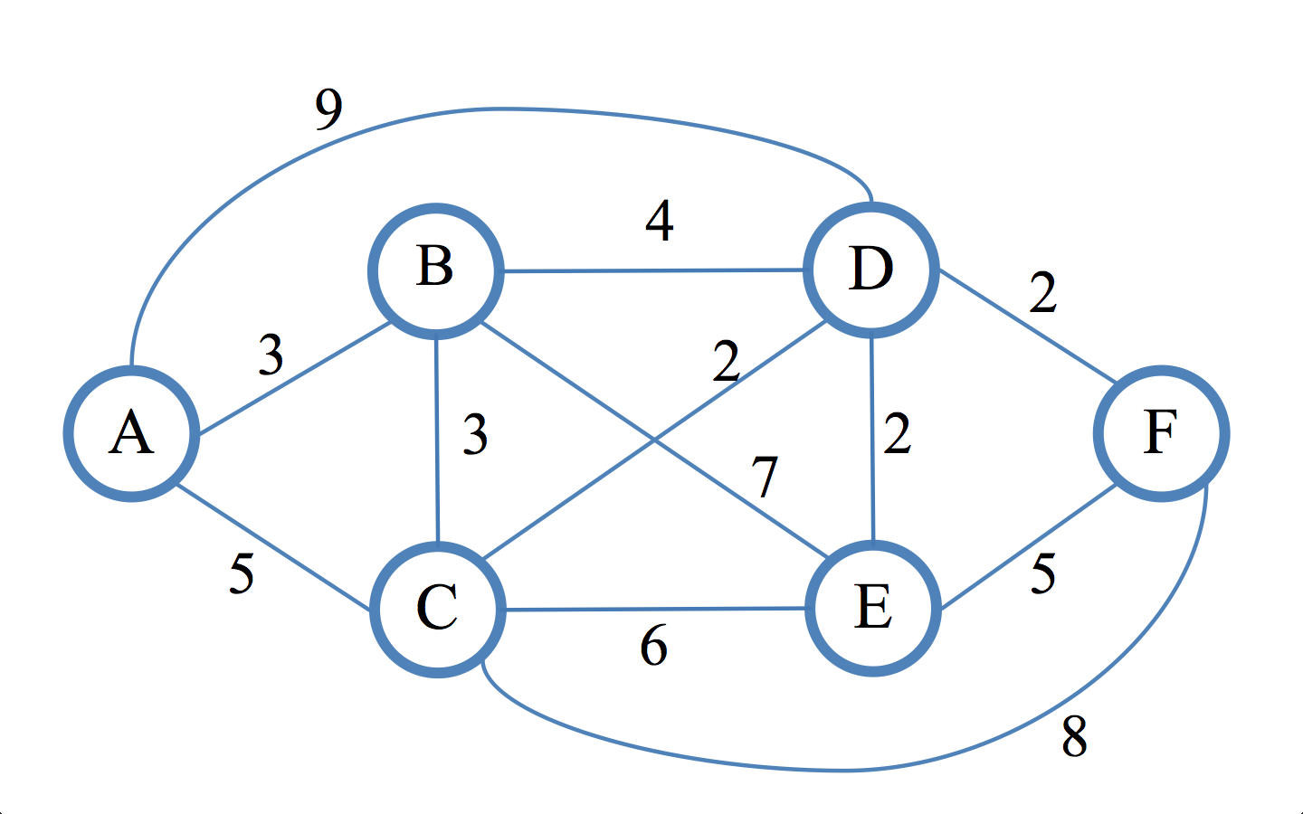

1. Explain in detail the concept of Hierarchical OSPF.
2. Explain how “Hot Potato routing” uses the concept of eBGP and iBGP, . You may illustrate your answer using a diagram.
3. Explain the concept of VLAN in detail, and how it improves the network performance.

7. Explain in detail, how slotted ALOHA is an improvement over ALOHA.

8. Consider the 5-bit generator, G = 10011, and D is given as under, what is the value of R?

D = 1010101010, 1001010101, 0101101010, 1010100000

9. Explain in detail, how ARP protocol is used to send datagrams from one LAN to another LAN.

10. Explain in detail, how MPLS capable routing is better than traditional IP routing.